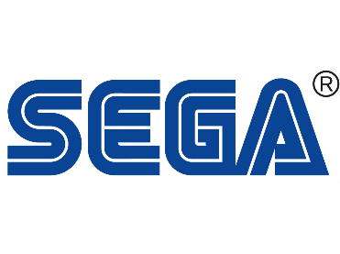
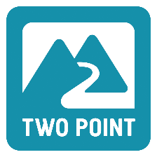
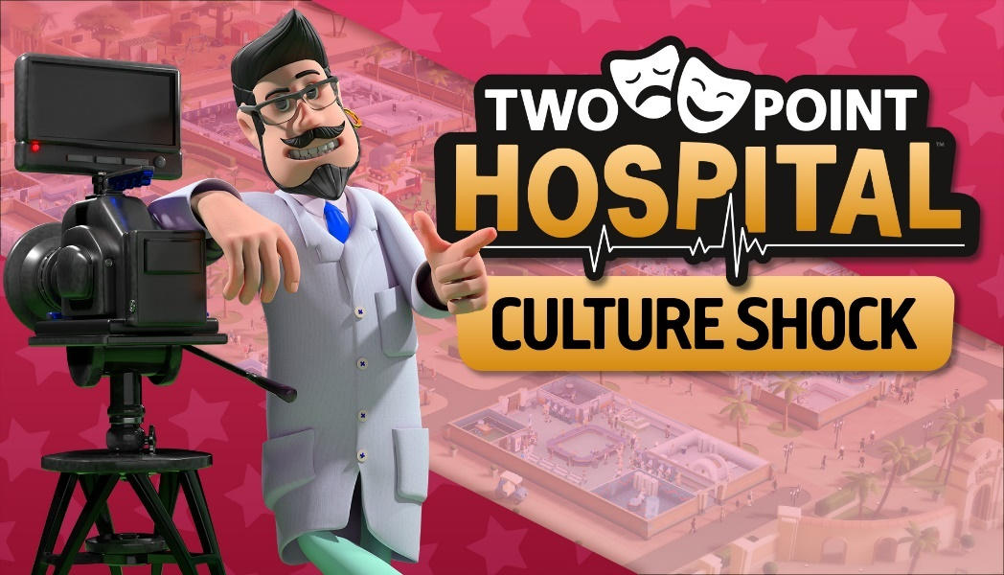
SAVE THE ARTISTIC WORLD
Two Point Hospital™: Culture Shock DLC coming to Steam 20 October 2020
London, England – 13 October 2020 – An artistic crisis is taking over Two Point County, where culture is drying up and a once vibrant arts scene is fading. SEGA® Europe Ltd. and Two Point Studios™ Ltd. are calling upon all Two Point Hospital fans to help cure the ailing culture of Two Point County in the all-new expansion ‘Culture Shock’. Culture Shock will be available on Steam from 20 October for £8.99 and is available for pre-purchase now, with an early adopter discount of 10% until 27 October 2020. Join Two Point County’s most devoted artist Zara Fitzpocket on her quest to save the world of arts: https://youtu.be/IQLgpglB_Pw
In Two Point Hospital: Culture Shock players will experience a world of lavish lifestyles, movie stars, festivals and of course…a party hospital. Before players can live out their wildest dreams, they are teaming up with the County’s very own celebs, to bring the television scene, music industry and the very arts themselves back to life. Culture Shock is still a hospital management simulation game where players will have to run hospitals, deal with troublesome staff and cure all sorts of new unusual illnesses like, Stunt Trouble, Private Parts, Concertoes and Writer’s Block.

In Two Point Hospital: Culture Shock players will start their new journey in the glitz and glamour of Plywood Studios, where launching a hit medical drama show could save the County’s artistic crisis or not… Head to Mudbury and experience festival life for yourself, while serving burgers from questionable vans. Lastly, celebrating the success of previous projects, players can finally live out their Hollywood dreams at Fitzpocket Academy, where art, glamour and hospitals (?!) come together. Culture Shock has the most (36!) new illnesses featured in any Two Point Hospital DLC yet, including twelve visual illnesses, but also three fabulous locations, three new fully animated cure machines, 34 new items to pimp up your hospitals and finally, make sure to turn up the sound, because there is a new DJ in town.

For anyone who’s fed up with their staff looking like actual professionals, make sure to check out the new Fancy Dress Item Pack next week, where tangy outfits, outrageous hats and diagnosed wizards are the new normal. The Fancy Dress Item Pack includes 23 outfits, headwear and items, and is available from the 20 October 2020 on Steam, where you can also claim a free Zombie costume.

Two Point Hospital: Culture Shock will only be available on Steam; for more information on Two Point Hospital on consoles and all other things Two Point Hospital, sign up for our Hospital Pass newsletter at www.twopointhospital.com where you will receive the coveted in-game item, the Golden Bathroom Suite. You can also follow the game on YouTube, Facebook and Twitter. For more information about SEGA Europe, visit www.sega.co.uk, follow us on Instagram, Twitter, YouTube, Twitch or Facebook.
About Two Point Studios Ltd.
Two Point Studios Ltd. is a British game developer, based in Farnham, Surrey (UK) and was founded in 2016. Two Point Studios’ small, but dedicated and passionate team have worked on some of the most recognisable brands in gaming, including Fable and Black and White. Drawing on that experience, Two Point Studios released a brand-new IP in the sim genre called Two Point Hospital, which launched for PC in August 2018. For more information about Two Point Studios visit www.twopointstudios.com.

About SEGA® Europe Ltd.:
SEGA Europe Ltd. is the European Distribution arm of Tokyo, Japan-based SEGA CORPORATION, and a worldwide leader in interactive entertainment both inside and outside the home. The company develops and distributes interactive entertainment software products for a variety of hardware platforms including PC, wireless devices, and those manufactured by Nintendo, Microsoft and Sony Interactive Entertainment Europe. SEGA wholly owns the video game development studios Two Point Studios, Creative Assembly, Relic Entertainment, Amplitude Studios, Sports Interactive and HARDlight. SEGA Europe’s website is located at www.sega.co.uk

